

**Milestone 1 – Table Creation (DDL) and INSERT Statements (DML)**

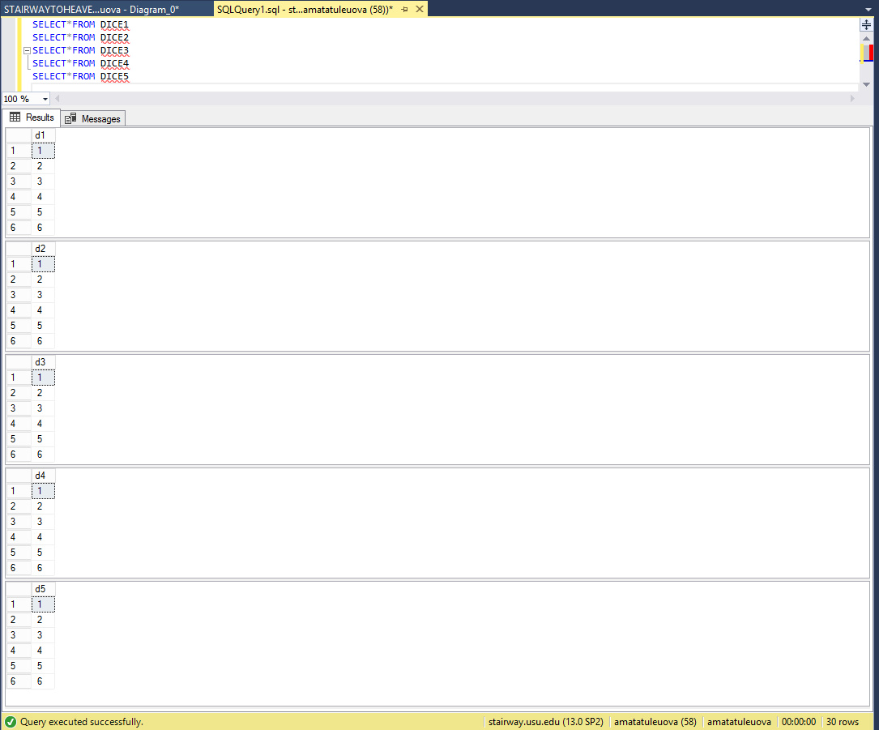

**Milestone 2 – CROSS JOIN,  Random Number, and TOP FUNCTION**

1. 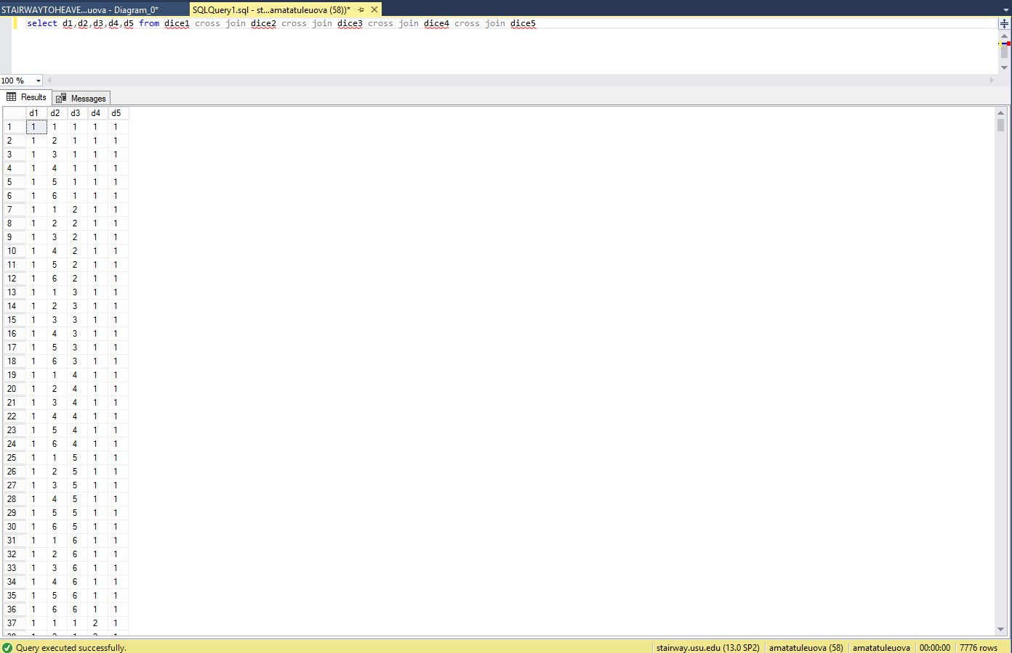
2. 7,776 rows are created with the CROSS JOIN
3. 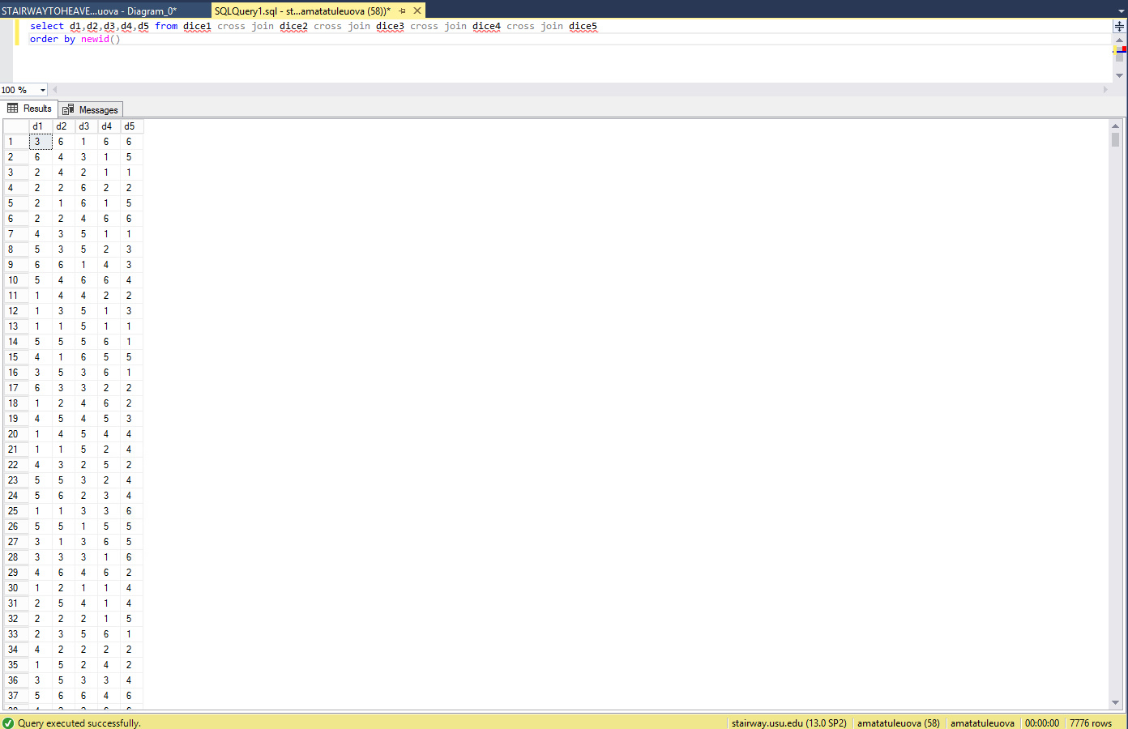

**Milestone 3 – Calculated Column & CASE EXPRESSION**

1. 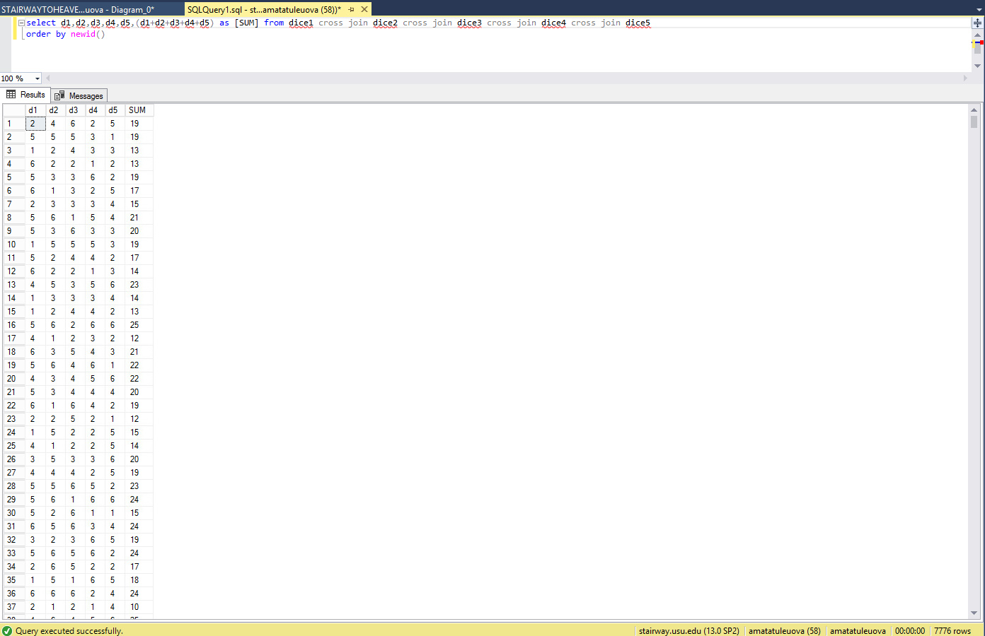

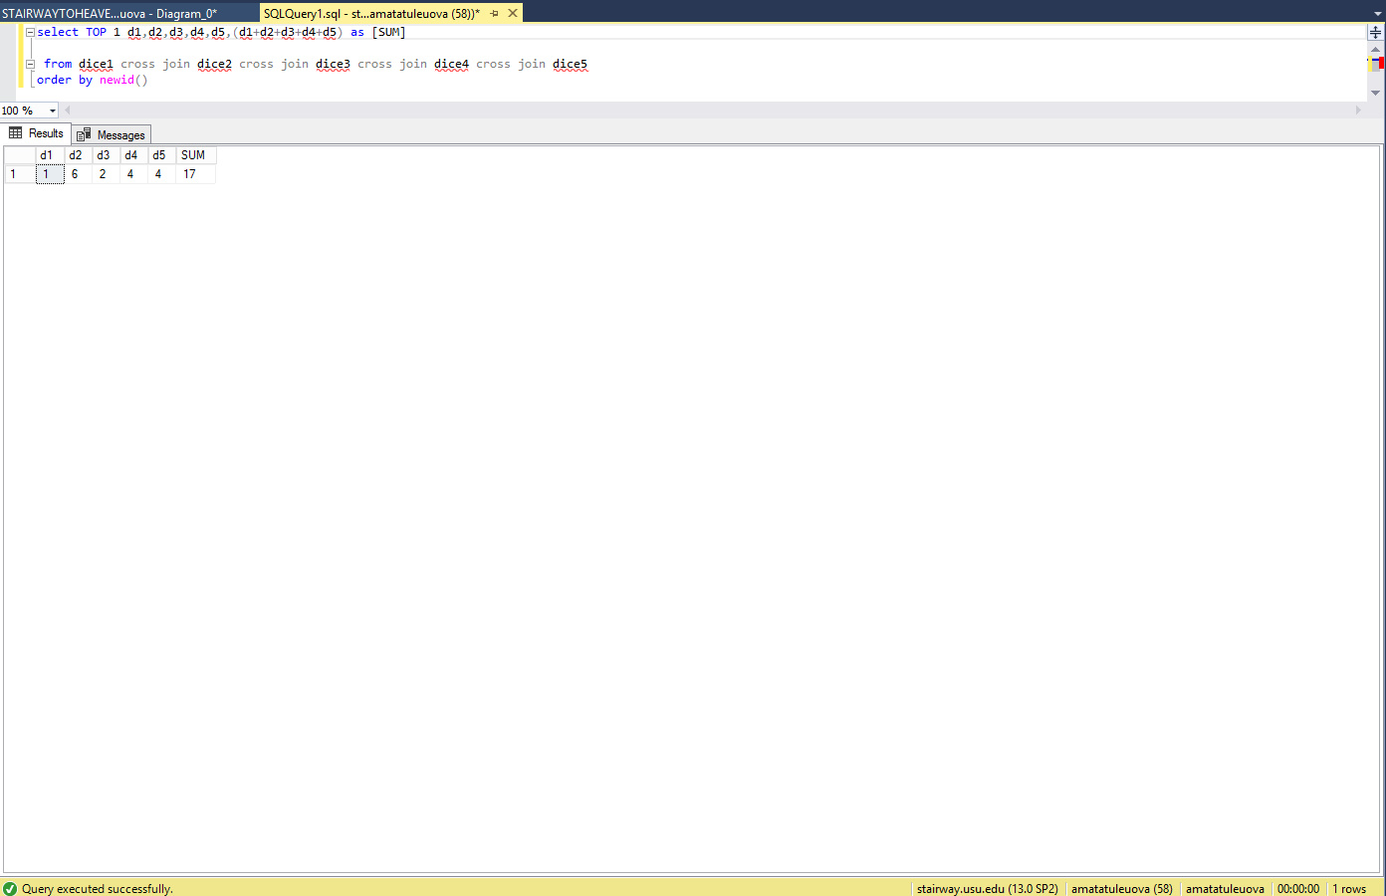

1. 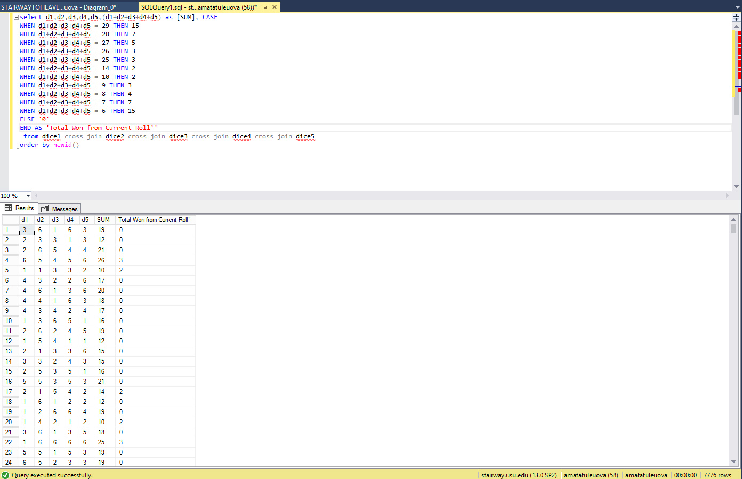

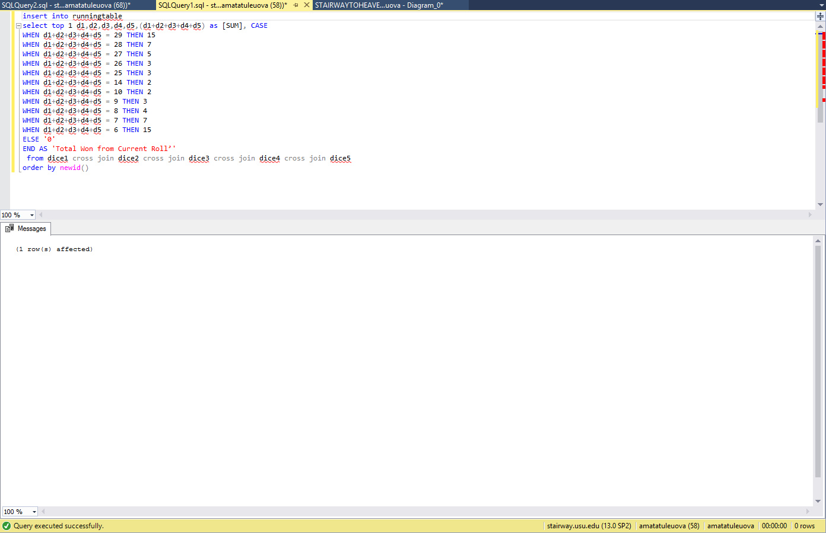

**Milestone 4 – INSERT INTO SELECT STATEMENT**



**Milestone 5 – WINDOW FUNCTION**

insert into runningtable

select top 1 d1,d2,d3,d4,d5,(d1+d2+d3+d4+d5) as [SUM], CASE

WHEN d1+d2+d3+d4+d5 = 29 THEN 15

WHEN d1+d2+d3+d4+d5 = 28 THEN 7

WHEN d1+d2+d3+d4+d5 = 27 THEN 5

WHEN d1+d2+d3+d4+d5 = 26 THEN 3

WHEN d1+d2+d3+d4+d5 = 25 THEN 3

WHEN d1+d2+d3+d4+d5 = 14 THEN 2

WHEN d1+d2+d3+d4+d5 = 10 THEN 2

WHEN d1+d2+d3+d4+d5 = 9 THEN 3

WHEN d1+d2+d3+d4+d5 = 8 THEN 4

WHEN d1+d2+d3+d4+d5 = 7 THEN 7

WHEN d1+d2+d3+d4+d5 = 6 THEN 15

ELSE '0'

END AS 'Total Won from Current Roll’'

from dice1 cross join dice2 cross join dice3 cross join dice4 cross join dice5

order by newid()

SELECT TOP 1 RollNum, d1, d2, d3, d4, d5, SUM as 'Sum of Current roll',

total as 'Points Earned on Current Roll',

SUM(TOTAL) OVER (ORDER BY RollNum) as 'Total Overall Score'

from runningtable

ORDER BY RollNUM DESC

